 | 19.3.3 Editors - Drivers Editor - Sidebar - Modifiers Tab
Table of content
Detailed table of content 1
Modifiers Tab - Modifiers Panel 3
Modifier header 3
Generator modifier 4
Built- in Function modifier 5
Envelope modifier 6
Cycles modifier 8
Noise modifier 9
Limits modifier 10
Stepped Interpolation modifier 11

Detailed table of content
Detailed table of content
Detailed table of content 1
Modifiers Tab - Modifiers Panel 3
Add Modifier 3
Copy F-Curve Modifiers 3
Paste F-Curve Modifiers 3
Last Operator Add F-Curve Modifier 3
Type 3
Only Active 3
Modifier header 3
Triangle button 4
Active 4
Modifier name 4
Muted 4
Delete F-Curve Modifier 4
Generator modifier 4
Polynomial Mode 4
Additive 4
Poly Order Expanded mode 4
Poly Order Factorized mode 5
Restrict Frame Range 5
Start / End 5
In / Out 5
Use Influence 5
Influence 5
Built- in Function modifier 5
Curve Type 5
Amplitude 5
Phase Multiplier 6
Phase Offset 6
Value Offset 6
Restrict Frame Range 6
Start / End 6
In / Out 6
Use Influence 6
Influence 6
Envelope modifier 6
Envelope 7
Reference Value 7
Min 7
Max 7
Control Points 7
Add Point 7
Point values 7
Frame 7
Min 7
Max 7
Delete 7
Restrict Frame Range 7
Start / End 7
In / Out 8
Use Influence 8
Influence 8
Cycles modifier 8
Trivially Cyclic Curves 8
Before 8
Before Cycles 8
After 8
After Cycles 9
Restrict Frame Range 9
Start / End 9
In / Out 9
Use Influence 9
Influence 9
Noise modifier 9
Blend Type 9
Scale 9
Strength 10
Offset 10
Phase 10
Depth 10
Restrict Frame Range 10
Start / End 10
In / Out 10
Use Influence 10
Influence 10
Limits modifier 10
Minimum / Maximum X 11
Minimum / Maximum Y 11
Restrict Frame Range 11
Start / End 11
In / Out 11
Use Influence 11
Influence 11
Stepped Interpolation modifier 11
Step Size 11
Offset 11
Use Start Frame 12
Use End Frame 12
Restrict Frame Range 12
Start / End 12
In / Out 12
Use Influence 12
Influence 12

Modifiers Tab - Modifiers Panel

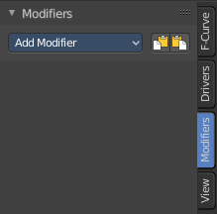
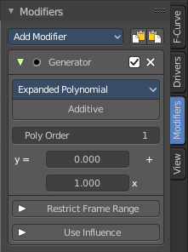
F-Curve modifiers are similar to Object modifiers. They allow to add adjustable non destructive effects. And they can be layered on top of each other.

Different to the Object modifiers you can't reorder this modifiers. You have to create it in the order that you need it.

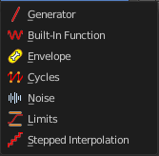
Add Modifier
The list of modifiers. Choose by clicking.

Copy F-Curve Modifiers
Copy the F-Curve Modifiers of the active F-Curve.

Paste F-Curve Modifiers
Paste copied F-Curve modifiers to the active F-Curve.

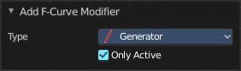
Last Operator Add F-Curve Modifier

Type
A drop down list with the Type of modifier to add.

Only Active
Only add a modifier to the currently active curve.

Modifier header

Every modifier is a panel. And every panel has a header area with some general UI elements.

Triangle button
Every modifier panel can be expanded or collapsed by clicking at this triangle button.

Active
This is the panel that you currently edit. When you edit a panel while it is not set to the active one, then the changes will not be applied.

Modifier name
The name of the modifier. Read only.

Muted
Enable or disable this modifier.

Delete F-Curve Modifier
Delete this modifier.

Generator modifier
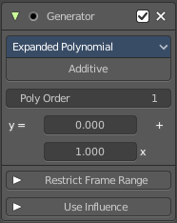

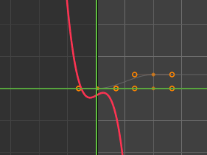
Polynomial Mode
Use Expanded Polynominal or Factorized Polynominal algorithm. With these mathematical formulas you can create lines, parabolas, and other more complex curves by changing the values in the poly order field.

Additive
Add on top of the existing curve instead of replacing the existing curve.

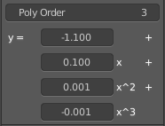
Poly Order Expanded mode
The polynominal formula for the Expanded mode. By increasing the Poly Order value you can add more polynomial fields to the formula.
Change the values to the desired results.

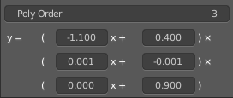
Poly Order Factorized mode
The polynominal formula for the Factorized mode. By increasing the Poly Order value you can add more polynomial fields to the formula.
Change the values to the desired results.

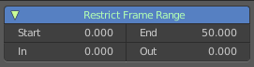
Restrict Frame Range
Expanding the Restrict Frame range sets it to active. It reveals some value slider then.

Start / End
The start and end frame of the generated curve.

In / Out
Fade the curve in or out for chosen frame numbers.

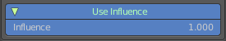
Use Influence
Temper the F-Curve Modifier effect by a default influence factor.
Expanding the Use Influence sets it to active. It reveals a value slider then.

Influence
The influence factor.

Built- in Function modifier

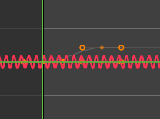
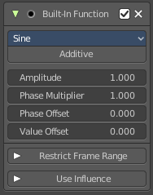
Generate a curve by built in functions.

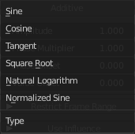
Curve Type
The available wave forms for the curve.

Amplitude
The amplitude of the curve wave. Adjusts the Y scaling.

Phase Multiplier
A phase multiplier for the curve wave. Adjusts the X scaling.

Phase Offset
A phase offset for the curve wave. Adjusts the Y scaling.

Value Offset
A constant value offset for the whole curve. Adjusts the X scaling.

Restrict Frame Range
Expanding the Restrict Frame range sets it to active. It reveals some value slider then.

Start / End
The start and end frame of the generated curve.

In / Out
Fade the curve in or out for chosen frame numbers.

Use Influence
Temper the F-Curve Modifier effect by a default influence factor.
Expanding the Use Influence sets it to active. It reveals a value slider then.

Influence
The influence factor.

Envelope modifier
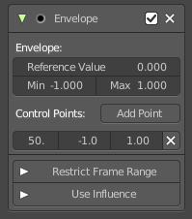
The Envelope modifier allows you to modify the overall shape of the curve by control points.
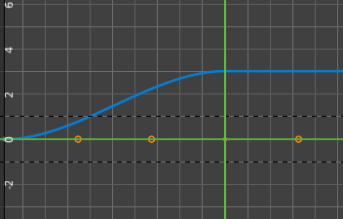
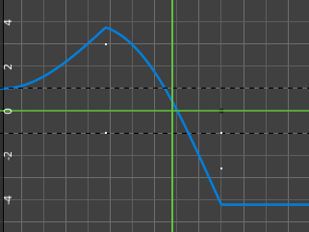

Envelope

Reference Value
Set the Y value to center the envelope around.

Min
The lower distance from reference value for 1:1 default influence.

Max
The higher distance from reference value for 1:1 default influence.

Control Points

Add Point
Add a control point. A control point has two sub points, a lower control point and a higher control point.

Point values
Adding a control point adds an entry in the Point Values list. Every added control point has its own values that can be modified here.

Frame
The frame position of this control point.

Min
The position of the lower control point.

Max
The position of the higher control point.

Delete
Delete this envelope control point.

Restrict Frame Range
Expanding the Restrict Frame range sets it to active. It reveals some value slider then.

Start / End
The start and end frame of the generated curve.

In / Out
Fade the curve in or out for chosen frame numbers.

Use Influence
Temper the F-Curve Modifier effect by a default influence factor.
Expanding the Use Influence sets it to active. It reveals a value slider then.

Influence
The influence factor.

Cycles modifier
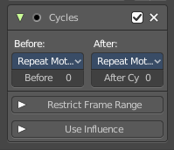
Add a cyclic motion to a curve that has two or more control points. The option can be set before or after the curve.

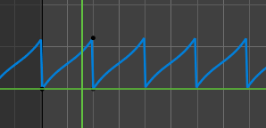
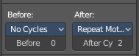
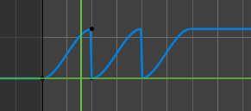

Trivially Cyclic Curves
When the Cycle Mode for both ends is set to either Repeat Motion or Repeat with Offset, and no other options of the modifier are changed from their defaults, it defines a simple infinite cycle.
This special case receives some additional support from other areas of Blender:
Automatic Bezier handle placement is aware of the cycle and adjusts to achieve a smooth transition.
The Cycle-Aware Keying option can be enabled to take the cycle into account when inserting new keyframes.

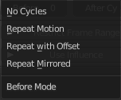
Before
Set the cycle mode before the first keyframe.

Before Cycles
Maximum number of cycles to allow before first keyframes. A value of 0 means infinite.

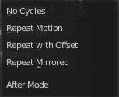
After
Set the cycle mode after the first keyframe.

After Cycles
Maximum number of cycles to allow after last keyframes. A value of 0 means infinite.

Restrict Frame Range
Expanding the Restrict Frame range sets it to active. It reveals some value slider then.

Start / End
The start and end frame of the generated curve.

In / Out
Fade the curve in or out for chosen frame numbers.

Use Influence
Temper the F-Curve Modifier effect by a default influence factor.
Expanding the Use Influence sets it to active. It reveals a value slider then.

Influence
The influence factor.

Noise modifier
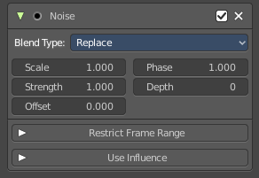
Adds noise to the curve.

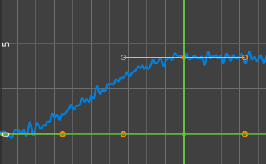

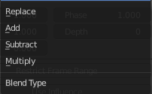
Blend Type
How to blend the noise with the curve.

Scale
The overall size of the noise. The bigger the value the less frequent the noise.

Strength
Adjust the Y value of the noise.

Offset
Time offset of the noise.

Phase
The random seed for the noise.

Depth
How detailed the noise function is.

Restrict Frame Range
Expanding the Restrict Frame range sets it to active. It reveals some value slider then.

Start / End
The start and end frame of the generated curve.

In / Out
Fade the curve in or out for chosen frame numbers.

Use Influence
Temper the F-Curve Modifier effect by a default influence factor.
Expanding the Use Influence sets it to active. It reveals a value slider then.

Influence
The influence factor.

Limits modifier

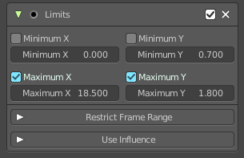
Sets limits to the curve in specified x and y range values.

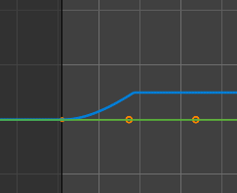

Minimum / Maximum X
Cuts the curve at these minimum and maximum frame values.

Minimum / Maximum Y
Clamps the curve at these minimum and maximum values.

Restrict Frame Range
Expanding the Restrict Frame range sets it to active. It reveals some value slider then.

Start / End
The start and end frame of the generated curve.

In / Out
Fade the curve in or out for chosen frame numbers.

Use Influence
Temper the F-Curve Modifier effect by a default influence factor.
Expanding the Use Influence sets it to active. It reveals a value slider then.

Influence
The influence factor.

Stepped Interpolation modifier

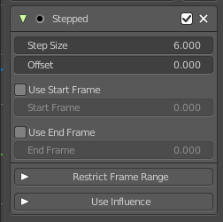
Adds steps to the curve by rounding the values.

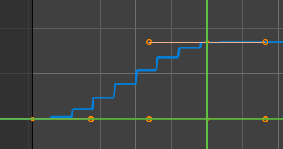

Step Size
The number of frames to hold each frame

Offset
A number of offset frames before frames get held.

Use Start Frame
Restrict the modifier so that it just acts before its end frame.

Use End Frame
Restrict the modifier so that it just acts after its start frame.

Restrict Frame Range
Expanding the Restrict Frame range sets it to active. It reveals some value slider then.

Start / End
The start and end frame of the generated curve.

In / Out
Fade the curve in or out for chosen frame numbers.

Use Influence
Temper the F-Curve Modifier effect by a default influence factor.
Expanding the Use Influence sets it to active. It reveals a value slider then.

Influence
The influence factor.

